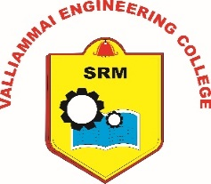
SRM VALLIAMMAI ENGINEERING COLLEGE
(An Autonomous Institution)
SRM Nagar, Kattankulathur – 603 203.

Ph.D Course Work Registration Form
Name of the Scholar with Address&
Mobile Number
Anna University Register No.
Email Id.
Name of Supervisor with Address&
Mobile No.
Category of Registration(FT/PT)& Centre

Details of Course Works to be registered in COE-SRMVEC:
 | Subject-1 | Subject-2
Academic Year
Semester (Odd / Even )
Department Offering Course
Name of Course (PG Offering )e.g.M.E.(PSE)
Subject Code
Subject Name
Name of Subject Incharge&Department
Signature of Sub Incharge
ERP ID

Signature of Scholar Signature of Supervisor

To,
The Principal, SRMVEC.

