SRM VALLIAMMAI ENGINEERING COLLEGE
(An Autonomous Institution)
SRM Nagar, Kattankulathur – 603 203
DEPARTMENT OF ELECTRONICS AND COMMUNICATION ENGINEERING

QUESTION BANK

III SEMESTER
EC3366 DIGITAL SYSTEMS DESIGN
Academic Year 2026 – 2027 (ODD Semester)
Prepared by
Mr.V.Prasanan, Assistant Professor (O.G)
Dr. N.Jothy, Assistant Professor (Sr.G)
Dr. T.Prasath, Assistant Professor (Sr.G)



SRM VALLIAMMAI ENGINEERING COLLEGE
(An Autonomous Institution)

SRM Nagar, Kattankulathur – 603 203.

DEPARTMENT OF ELECTRONICS & COMMUNICATION ENGINEERING

QUESTION BANK

SUBJECT CODE/NAME :EC3366 / DIGITAL SYSTEMS DESIGN

YEAR / SEMESTER : II / III

UNIT I DIGITAL FUNDAMENTALS
Number Systems – Decimal, Binary, Octal, Hexadecimal, 1‘s and 2‘s complements, Codes – Binary, BCD, Excess 3, Gray, Alphanumeric codes, Boolean theorems, Logic gates, Universal gates, Sum of products and product of sums, Minterms and Maxterms, Karnaugh map and Quine-McCluskey methods.
PART A
Q.No | Questions |  | CO | BT Level | Domain
 | Convert the given decimal numbers into their binary equivalent (108.364)_{10 .} |  | CO1 | BTL 2 | Understanding
 | Convert the binary number 1011 to its decimal equivalent. |  | CO1 | BTL 2 | Understanding
 | Compare Binary code and BCD code briefly. |  | CO1 | BTL 3 | Applying
 | Outline the concept of duality in Boolean algebra. |  | CO1 | BTL 1 | Remembering
 | Convert A3B_{H} and 2F3_{H} into Binary and Octal respectively |  | CO1 | BTL 2 | Understanding
 | Discuss the importance of Boolean theorems in simplifying logic circuits. |  | CO1 | BTL 2 | Understanding
 | Convert (115)₁₀ into hexadecimal numbers. |  | CO1 | BTL 2 | Understanding
 | Define ‘Minterm’ and ‘Maxterm’. |  | CO1 | BTL 1 | Remembering
 | State the Boolean theorem for commutativity. |  | CO1 | BTL 1 | Remembering
 | Draw the active high tri-state Gate & write its truth table. |  | CO1 | BTL 1 | Remembering
 | Illustrate the operation of an AND gate with its truth table. |  | CO1 | BTL 2 | Understanding
 | Write the principle of Distributive law. |  | CO1 | BTL 1 | Remembering
 | What is meant by Prime Implicants and Essential prime implicants? |  | CO1 | BTL 1 | Remembering
 | Discuss the importance of Boolean theorems in simplifying logic circuits. |  | CO1 | BTL 2 | Understanding
 | Compute the given function using NAND gates only.  F(X, Y, Z) =$\sum{m(0,6)}$. |  | CO1 | BTL 2 | Understanding
 | Write the equivalent Gray code for [10110]₂. |  | CO1 | BTL 1 | Remembering
 | Differentiate between SOP and POS forms with an example. |  | CO1 | BTL 2 | Understanding
 | Explain each step of the simplification process for the given expression $\overline{A+B\overline{C}}$ using De-Morgan’s theorem. |  | CO1 | BTL 2 | Understanding
 | Demonstrate how to implement Y = ∑(1, 4, 5, 6, 7) in SOP form using AOI (AND-OR-Invert) logic. |  | CO1 | BTL 2 | Understanding
 | Determine the Boolean expression for the output of the system shown in figure.  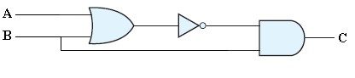 |  | CO1 | BTL 2 | Understanding
 | Summarize the steps involved in the Quine-McCluskey method |  | CO1 | BTL 2 | Understanding
 | Interpret the Boolean function and the truth table of the given logic.  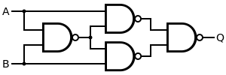 |  | CO1 | BTL 2 | Understanding
 | Interpret the Boolean expression for the output of the system shown in the figure and explain the process used to derive it.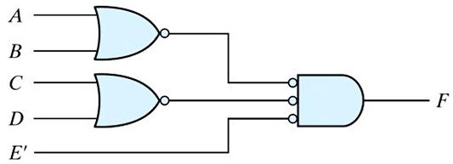 |  | CO1 | BTL2 | Understanding
 | Simplify the expression $A\overline{B}C+\overline{A}\overline{B}C$ using Boolean theorems. |  | CO1 | BTL 2 | Understanding
PART – B
 | Simplify the Minimized logic function using K-Maps.  F (A, B, C, D) = ∑m (1,3,5,8,9,11,15)+ ∑d(2,13). Implement the minimal SOP using NAND and NOR gates. | (16) | CO1 | BTL3 | Applying
 | Use the K-map method to find the minimal function for  F(A,B,C,D,E) = ∑m(1,4,6,10,20,22,24,26) + ∑d(0,11,16,27). Draw the circuit of the minimal expression using basic gates. | (16) | CO1 | BTL 3 | Applying
 | Analyze the given function Y (M, N, O, P, Q) =$\sum{m(0,2,4,6,9,13,21,23,25,29,31})$. Draw the K-map and implement the simplified expression using basic gates. | (16) | CO1 | BTL 4 | Analyzing
 | Analyze and minimize the following Boolean expressions using Boolean algebra. Draw the logic diagram for the minimized expressions.  (i) F (X, Y, Z) =$(X+Y)\left(\overline{\overline{X}\left(\overline{Y}+\overline{Z}\right)}\right)+\overline{X}\overline{Y}+\overline{X}\overline{Z}$.  (ii) F (X, Y, Z) =$\overline{X}\overline{Y}Z+\overline{X}YZ+X\overline{Y}$ (iii) F(X,Y,Z) =$XYZ+\overline{X}Z+YZ$ | (6)  (5)  (5) | CO1 | BTL 4 | Analyzing
 | - Apply your knowledge to explain Excess-3 codes and Gray Code  with an example.  - Convert the Gray code (110101) to Binary code.  - Convert the binary number (10101101)₂ to Gray code | (6)  (5)  (5) | CO1 | BTL 3 | Applying
 | Simplify the minimized Boolean expression for the function using K-map and draw the logic diagram.  F (w, x, y,z)=$\sum{m(0,1,2,4,5,6,8,9,12,13,14)}$. | (16) | CO3 | BTL 3 | Applying
 | Illustrate the logical Expression on a 4-variable K – map F=ABCD+AB’C’D’+AB’C+AB & realize using only NAND gates. | (16) | CO1 | BTL 3 | Applying
 | Elaborate the minimization of the given Boolean function using  Quine-Mc-Cluskey method F=∑m (0,1,2,5,7,8,9,10,13,15). Realize the simplified function using logic gates. | (16) | CO1 | BTL 4 | Analyzing
 | Using K-map method, simplify the given Boolean function and obtain minimum POS expression and draw the logic diagram.  X=$\prod{m(1,3,5,7,9)}+\prod{d(8,11,15)}$. | (16) | CO1 | BTL 3 | Applying
 | Solve the following Function using Tabulation method  F=∑m(1,2,3,7,8,9,10,11,14,15) and realize the circuit using logic gates. | (16) | CO1 | BTL 3 | Applying
 | (i) Convert (725.25)₈ to its decimal, binary and Hexadecimal  equivalent.  (ii) Find 1’s and 2’s Complement of 8-digit binary number 10101101. | (8)  (8) | CO1 | BTL 3 | Applying
 | - Implement Y=$(A+C)(A+\overline{D})(A+B+\overline{C})$  (ii) Solve by perfect induction  (a) A+AB = A  (b) A(A+B) = A  (c) A+A’B = A+B and  (d) A(A’+B) =AB | (8)  (8) | CO1 | BTL 3 | Applying
 | Minimize the following Boolean function using K-map and implement the same using only NAND gates.  F(A, B, C, D) = (D’+A’B’C’ + AB’C’ + A’BC’D). | (16) | CO1 | BTL 3 | Applying
 | Determine simplified SOP for the following Boolean function using Quine- McCluskey Method.  F(A, B, C, D) = ∑m(1, 3, 4, 5, 9, 10, 11) + ∑d(6, 8). | (16) | CO1 | BTL 3 | Applying
15. | Design the given function using Prime implicant method and Verify your result using K map F=$\sum{m(0,1,2,4,5,6,8,9,12,13,14)}$. | (16) | CO1 | BTL 3 | Applying
16. | Construct a Karnaugh Map for the following function  F(A,B,C,D,E)= $\sum{(0,5,6,8,9,10,11,16,20,24,25,26,27,29,31)}$ and draw the logic diagram. | (16) | CO1 | BTL 3 | Applying
17. | Simplify the SOP form of the function  F(A,B,C,D) = ∑m(0, 2, 6 ,8, 10, 12, 14, 15) and implement using basic gates.  $\sum{m(0,1,2,4,5,6,8,9,12,13,14)}$ | (16) | CO1 | BTL 4 | Analyzing

UNIT II COMBINATIONAL CIRCUIT DESIGN
Design of Half and Full Adders, Half and Full Subtractors, Binary Parallel Adder – Carry look ahead Adder, BCD Adder, Multiplexer, Demultiplexer, Decoder, Encoder, Priority Encoder, Magnitude Comparator, Case study: 8 bit Arithmetic and logic unit.

PART A
Q.No | Questions |  | CO | BT Level | Domain
 | Define combinational circuits. |  | CO2 | BTL 1 | Remembering
 | Name some of the combinational circuits. |  | CO2 | BTL 2 | Understanding
 | Summarize the design procedure of combinational circuits. |  | CO2 | BTL 2 | Understanding
 | Write the Boolean expression for a half adder. |  | CO2 | BTL 1 | Remembering
 | Construct a Full Adder circuit using XOR, AND, and OR gates. |  | CO2 | BTL 2 | Understanding
 | From the truth table derive the logic equation of a half subtractor. |  | CO2 | BTL2 | Understanding
 | Explain how a Carry Look-Ahead Adder (CLA) overcomes the speed limitation of ripple carry adders. |  | CO2 | BTL 2 | Understanding
 | Differentiate between half adder and full adder. |  | CO2 | BTL 2 | Understanding
 | Why is MUX called as a data selector? |  | CO2 | BTL 2 | Understanding
 | List out the applications of multiplexer. |  | CO2 | BTL 1 | Remembering
 | Mention the uses of demultiplexer. |  | CO2 | BTL 2 | Understanding
 | How the decoder functions as a demultiplexer? |  | CO2 | BTL 2 | Understanding
 | What do you mean by comparator? |  | CO2 | BTL 1 | Remembering
 | Determine the maximum number of outputs for a decoder with a 6-bit data word. |  | CO2 | BTL2 | Understanding
 | Point out the function of select inputs of a MUX. |  | CO2 | BTL 2 | Understanding
 | Discuss the operation of the multiplexer in routing the selected input to the output Y. |  | CO2 | BTL 1 | Remembering
 | Distinguish between a demultiplexer and decoder. |  | CO2 | BTL 2 | Understanding
 | Compare Multiplexer with Demultiplexer. |  | CO2 | BTL 2 | Understanding
 | Define priority encoder. |  | CO2 | BTL 1 | Remembering
 | State the uses of encoder. |  | CO2 | BTL 1 | Remembering
 | Mention the applications of Decoder. |  | CO2 | BTL 2 | Understanding
 | Examine the logic diagram of 2 to 4 decoder. |  | CO2 | BTL 2 | Understanding
 | Identify and describe the necessary components used for an 8-bit ALU. |  | CO2 | BTL2 | Understanding
 | How to design a 1-bit comparator using basic gates. |  | CO2 | BTL2 | Understanding
PART – B
 | (i)Explain the design procedure for combinational circuits.  (ii) Write a note on Carry Look Ahead adders. | (6)  (10) | CO2 | BTL3 | Applying
 | Describe the construction of a full adder using two half adder circuits. Include a logic diagram illustrating the connections between the components. | (16) | CO2 | BTL 3 | Applying
 | Discuss in detail about the following combinational circuits:  (i) Half subtractor  (ii) Full subtractor | (8)  (8) | CO2 | BTL 3 | Applying
 | Explain the working of 4-bit parallel adder with necessary diagram and example. | (16) | CO2 | BTL 3 | Applying
 | Construct a 4-bit BCD adder and with necessary illustrations. | (16) | CO2 | BTL 4 | Analyzing
 | Implement the following Boolean function using 8X1 multiplexer.  F(A,B,C,D)=$\overline{A}B\overline{D}$+ACD+$\overline{B}$CD+$\overline{A}\overline{C}$D | (16) | CO2 | BTL 3 | Applying
 | Formulate the following Boolean function using 4 x 1 multiplexers. 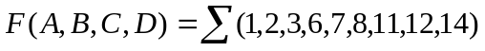. | (16) | CO2 | BTL 4 | Analyzing
 | Realize the function F(w, x, y, z)= Σm(1,4,6,7,8,9,10,11,15) using 4 to 1 Multiplexer. | (16) | CO2 | BTL 3 | Applying
 | Describe about multiplexer and Simplify the following function using 8x1 Mux F(A,B,C,D)=∑m(0,2,6,10,11,12,13)+d(3,8,14) | (16) | CO2 | BTL 4 | Analyzing
 | (i) Draw and explain the working of 1:8 demultiplexer and realize it  using basic gates?  (ii) Implement the following functions using demultiplexer:  F1(A,B,C)=∑m(0,3,7)  F2(A,B,C)=$∑m(1,2,5)$ | (8)  (8) | CO2 | BTL 4 | Analyzing
 | Design a 3X8 Priority encoder with truth table, Boolean expression and logic diagram. | (16) | CO2 | BTL 3 | Applying
 | Design a logic circuit using 4x1 Multiplexer which has four inputs A, B, C, and D. The output X of the circuit is logic 1 if two or more inputs are logic 1. | (16) | CO2 | BTL 3 | Applying
 | Explain about the purpose of decoder and implement a full adder and full subtractor using decoder. | (16) | CO2 | BTL 3 | Applying
 | (i) Design and implement the circuit using multiplexer which has 3 inputs (A,B,C) and one output Z. The output is HIGH, when the input is less than 3, otherwise 0.  (ii) Implement the function f(w1, w2, w3) = ∑m(0, 1, 3, 4, 6, 7) by using a 3-to-8 binary decoder and an OR gate. | (8)  (8) | CO2 | BTL 4 | Analyzing
 | Implement the following Boolean function using an 8:1 multiplexer considering D as the input and A,B,C as selection lines :  F( A, B, C, D) =AB’+BD+B’CD’ | (16) | CO2 | BTL 3 | Applying
 | Explain the following with necessary diagrams:  (i) Full adder using multiplexer.  (ii) Full subtractor using demultiplexer. | (8)  (8) | CO2 | BTL 3 | Applying
 | Design a 2-bit magnitude comparator with three outputs: A>B, A=B and A<B. | (16) | CO2 | BTL 4 | Analyzing

UNIT III SYNCHRONOUS SEQUENTIAL CIRCUITS
Flip flops – SR, JK, T, D, Master/Slave FF – operation and excitation tables, Triggering of FF, Analysis and design of clocked sequential circuits – Design - Moore/Mealy models, Design of Counters- Ripple Counters, Ring Counters, Shift registers, Universal Shift Register
PART A
Q.No | Questions |  | CO | BT Level | Domain
 | List the classification of Sequential circuits. |  | CO3 | BTL 1 | Remembering
 | Compare combinational and sequential circuits. |  | CO3 | BTL 2 | Understanding
 | Define a flip-flop. |  | CO3 | BTL 1 | Remembering
 | List the types of flip-flop. |  | CO3 | BTL 1 | Remembering
 | Differentiate between latch and flip-flop. |  | CO3 | BTL 2 | Understanding
 | Write the excitation table for JK Flip flop. |  | CO3 | BTL 1 | Remembering
 | Draw the state transition diagrams of flip-flops. |  | CO3 | BTL 2 | Understanding
 | Write the characteristic equation from the truth table of SR flip-flop. |  | CO3 | BTL 2 | Understanding
 | Transform a D flip-flop into a T flip-flop utilizing Boolean algebra and a truth table.  4o |  | CO3 | BTL2 | Understanding
 | Mention any two differences between the edge triggering and level triggering. |  | CO3 | BTL 2 | Understanding
 | Derive the characteristic equation for D flip-flop. |  | CO3 | BTL 2 | Understanding
 | Interpret the significance of state assignment. |  | CO3 | BTL 2 | Understanding
 | Illustrate the state diagram of Mod-10 counter. |  | CO3 | BTL 2 | Understanding
 | Draw the circuit diagram of ring Counter. |  | CO3 | BTL 1 | Remembering
 | Determine the number of flip-flops needed to construct a binary counter that counts from 0 to 1023. |  | CO3 | BTL2 | Understanding
 | Identify the difference between Mealy and Moore state machines.  4o |  | CO3 | BTL 1 | Remembering
 | What is the minimum number of flip-flops needed to design a counter of Modulus 10? |  | CO3 | BTL 1 | Remembering
 | List out the applications of shift registers. |  | CO3 | BTL 1 | Remembering
 | Distinguish between synchronous sequential circuits and asynchronous sequential circuits. |  | CO3 | BTL 2 | Understanding
 | Construct a NAND based logic diagram of JK FF. |  | CO3 | BTL1 | Remembering
 | Define universal shift register. |  | CO3 | BTL 1 | Remembering
 | Name the types of shift registers. |  | CO3 | BTL 1 | Remembering
 | Calculate the Q output for a J-K flip-flop with J = 1 and K = 1, given a 20 kHz clock input.  4o |  | CO3 | BTL 2 | Understanding
 | Sketch the 4-bit Johnson counter. |  | CO3 | BTL 2 | Understanding
PART – B
 | Define flip-flop and describe the operations of various types of flip-flops. Enumerate the applications where flip-flops are used. | (16) | CO3 | BTL 3 | Applying
 | Explain about JK flip-flop with truth table, characteristic equation and input & output waveforms. | (16) | CO3 | BTL 3 | Applying
 | Realize SR flip-flop using D flip-flop and JK flip-flop. | (16) | CO3 | BTL4 | Analyzing
 | (i)Describe the process involved in designing a clocked synchronous sequential circuit.  (ii) Obtain the reduced state table for the given tabulation. | (8)  (8) | CO3 | BTL 4 | Analyzing
  Present state | Next State |  | Output
  Present state | X = 0 | X =1 | X =0 | X=1
  a | F | b | 0 | 0
  b | D | c | 0 | 0
  c | F | e | 0 | 0
  d | G | a | 1 | 0
  e | D | c | 0 | 0
  f | F | b | 1 | 1
  g | G | h | 0 | 1
  h | G | a | 1 | 0
 | Describe the functions with the state diagram and characteristics equation of T FF. | (16) | CO3 | BTL 4 | Analyzing
 | Design a clocked sequential machine using T flip-flops for the following state diagram. Use state reduction if possible. Also use straight binary state assignment.  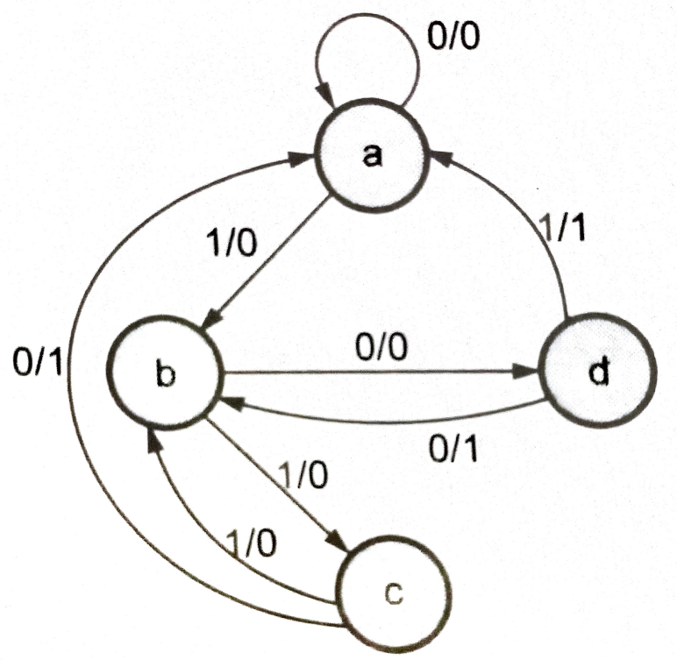 | (16) | CO3 | BTL 4 | Analyzing
 | Analyze the design procedure of a MOD-5 synchronous counter using JK flip-flops and implement it. | (16) | CO3 | BTL 4 | Analyzing
 | With the D flip-flop, design a synchronous counter which counts in the sequence 000,001,010,011,100,101,110,111,000. | (16) | CO3 | BTL3 | Applying
 | Using SR flip flops, design a counter which counts in the following sequence 000,111,1101,100,011,010,001, 000,….. | (16) | CO3 | BTL3 | Applying
 | Analyze a counter to count the sequence 0,1,2,4,5,6 using SR FFs. | (16) | CO3 | BTL 4 | Analyzing
 | Implement a J-K counter for the states 3, 4, 6, 7 and 3. | (16) | CO3 | BTL3 | Applying
 | Explain in detail about the working of mod-3 counter with neat diagram. | (16) | CO3 | BTL 3 | Applying
 | 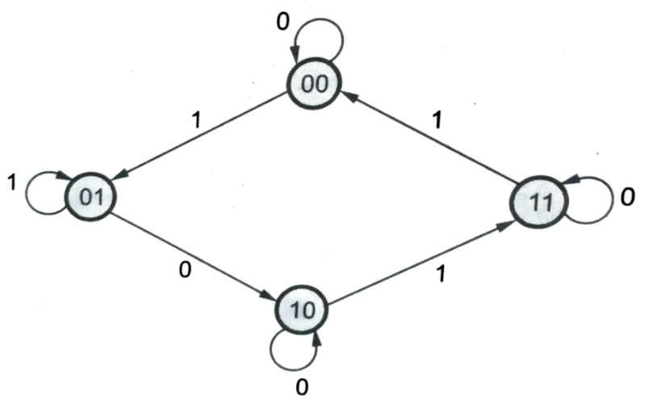  Analyze a synchronous sequential circuit using JK Flip-flop for the given state diagram. | (16) | CO3 | BTL 4 | Analyzing
14. | 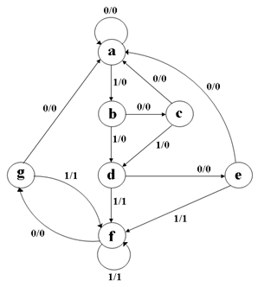  Construct a clocked synchronous sequential logic circuit using JK flip flops for the following state diagram. Use state reduction if possible. | (16) | CO3 | BTL 3 | Applying
15. | Draw the BCD ripple counter using JK flip-flop and label the logic diagram. | (16) | CO3 | BTL 1 | Remembering
16. | Design and implement 4-bit binary counter using D flip-flop which counts all possible odd numbers only. | (16) | CO3 | BTL 4 | Analyzing
17. | Analyze the operation of 4-bit SISO SIPO, PIPO and PISO shift register and draw its waveforms. | (16) | CO3 | BTL 4 | Analyzing

UNIT IV ASYNCHRONOUS SEQUENTIAL CIRCUITS

Stable and Unstable states, output specifications, Pulse mode sequential circuits, cycles and races, state reduction, race free assignments, Hazards, Essential Hazards, Design of Hazard free circuits.
PART A
Q.No | Questions |  | CO | BT Level | Domain
 | Mention the steps for the design of asynchronous sequential circuit. |  | CO4 | BTL 2 | Understanding
 | Identify the design steps of asynchronous sequential circuits. |  | CO4 | BTL 2 | Understanding
 | Compare fundamental mode and pulse mode sequential circuits |  | CO4 | BTL 2 | Understanding
 | Define dynamic hazard. When do they occur? |  | CO4 | BTL 1 | Remembering
 | What are pulse mode circuits? |  | CO4 | BTL 1 | Remembering
 | Write the difference between stable and unstable state. |  | CO4 | BTL 2 | Understanding
 | Specify the significance of state assignment. |  | CO4 | BTL 2 | Understanding
 | Outline the role of asynchronous sequential circuit in digital design. |  | CO4 | BTL 1 | Remembering
 | State the objective of state assignment asynchronous circuit. |  | CO4 | BTL 2 | Understanding
 | Define Hazards. How it can be avoided? |  | CO4 | BTL 1 | Remembering
 | Compare the Static-0 and Static-1 hazards. |  | CO4 | BTL 2 | Understanding
 | Examine the critical race condition in asynchronous sequential circuits with an example. |  | CO4 | BTL 2 | Understanding
 | Mention the causes of essential Hazard. |  | CO4 | BTL 2 | Understanding
 | Distinguish between critical race and non-critical race. |  | CO4 | BTL 2 | Understanding
 | Outline the characteristics of critical race. |  | CO4 | BTL 2 | Understanding
 | List the different techniques used in State assignment. |  | CO4 | BTL 1 | Remembering
 | Differentiate synchronous and asynchronous sequential circuits. |  | CO4 | BTL 1 | Remembering
 | How dynamic hazards can be avoided? |  | CO4 | BTL 2 | Understanding
 | Summarize the methods for critical-race free state assignment. |  | CO4 | BTL 1 | Remembering
 | Construct a K-map to remove static-1 hazard. |  | CO4 | BTL 2 | Understanding
 | Classify the modes of operation of sequential logic circuit. |  | CO4 | BTL 2 | Understanding
 | Examine the preference given to Hazard free design. |  | CO4 | BTL 1 | Remembering
 | Write the difference between cycles and races. |  | CO4 | BTL 1 | Remembering
 | Mention the effects due to Hazards in digital circuit. |  | CO4 | BTL 2 | Understanding
PART – B
 | Analyze an asynchronous sequential circuit with 2 inputs T and C. The output attains a value of 1 when T=1 and C moves from 1 to 0. Otherwise, the output is 0. | (16) | CO4 | BTL 4 | Analyzing
 | List the types of hazards. Check whether the following circuit contains a hazard or not Y = X₁X₂ + X₂′X_{3.} If the hazard is present, show the removal of hazard. | (16) | CO4 | BTL 3 | Applying
 | An asynchronous sequential circuit is described by the following excitation and output function. Y= X1X2+(X1+X2) Y, Z=Y.  (i) Construct the logic diagram.  (ii) Develop the transition table and output map.  (iii) Identify the behavior of the circuit | (4)  (6)  (6) | CO4 | BTL 3 | Applying
 | Construct hazard free realization for the following Boolean function.  F (A, B, C, D) = ∑m (1,5,6,7) using AND- OR gate network. | (16) | CO4 | BTL 3 | Applying
 | (i) Distinguish the design procedure for an asynchronous sequential circuit.  (ii) Analyze the state table of serial binary adder with neat diagram. | (10)  (6) | CO4 | BTL 4 | Analyzing
 | Explain how to design a circuit that has no static hazards and implement the Boolean function F(A,B,C,D) = Σ (0,2,6,7,8,10,12) using AND-OR logic. | (16) | CO4 | BTL 3 | Applying
 | Identify the challenges encountered in an asynchronous sequential circuit and elaborate on two specific issues in detail. | (16) | CO4 | BTL 3 | Applying
 | (i) Illustrate in detail about Races.  (ii) Explain the different methods of state assignment. | (8)  (8) | CO4 | BTL 3 | Applying
 | Discuss hazards in digital circuits, including static hazards, dynamic hazards, and essential hazards, supported by clear diagrams. | (16) | CO4 | BTL 3 | Applying
 | Examine the analysis procedure for asynchronous sequential circuits with necessary illustrations. | (16) | CO4 | BTL 4 | Analyzing
 | Illustrate about different hazards that occur in sequential circuits and also about the way to eliminate them. | (16) | CO4 | BTL 3 | Applying
 | Select the methods of Race Free State assignment and explain in detail. | (16) | CO4 | BTL 3 | Applying
 | Design an Asynchronous sequential circuit with input A and B and an output Y. Initially at any time if both the inputs are 0, the output, Y=0. When A or B = 1, Y =1. When the other input also become 1, Y=0. The output stays at 0 until circuit goes back to initial state. | (16) | CO4 | BTL 4 | Analyzing
 | Analyze in detail about state table, stable and unstable state with examples. | (16) | CO4 | BTL 4 | Analyzing
 | How the Hazard free circuit is designed? Explain with suitable example. | (16) | CO4 | BTL 3 | Applying
16. | Design an asynchronous sequential circuit with two inputs X and Y and with one output Z. Whenever Y is one, input X is transferred to Z. When Y is zero, the output does not change for any change in X. | (16) | CO4 | BTL 4 | Analyzing
17. | An Asynchronous sequential circuit has two internal states and one output. The excitation and output function describing the circuit is as follows:  Y1 = x₁x₂+x₁y₂+x₂y₂  Y2 = x₂+x₁y₁y₂+x₁y₁  Z = x₂+y₁.  - Draw the logic diagram.  - Derive transition table and output map. | (16) | CO4 | BTL 3 | Applying
UNIT - V MEMORY DEVICES AND INTRODUCTION TO HDL PROGRAMMING
Basic memory structure- ROM-PROM-EPROM-EEPROM-EAPROM, RAM – Static and Dynamic RAM- Programmable Logic Devices-Programmable Logic Array (PLA) – Programmable Array Logic (PAL). Introduction to HDL: Behavioral – data flow, and algorithmic and structural description, Examples for Combinational and Sequential circuits-Adders-Multiplexer-demultiplexer-Encoder-Decoder-Flipflops-Shift registers.
PART A
Q.No | Questions |  | CO | BT Level | Domain
 | Write the difference between ROM and RAM. |  | CO5 | BTL 1 | Remembering
 | Distinguish between volatile and non-volatile memory. |  | CO5 | BTL 2 | Understanding
 | Mention the advantages of DRAM cell over SRAM cell. |  | CO5 | BTL 2 | Remembering
 | What is programmable logic array? |  | CO5 | BTL 1 | Remembering
 | A certain memory has a capacity of 32k x 16. How many bits are there in each word? How many words are being stored and how many memory cells does this memory contain? |  | CO5 | BTL 2 | Understanding
 | What is memory decoding? |  | CO5 | BTL 1 | Remembering
 | Draw the circuitry used to realize 2-bit multiplier using ROM. |  | CO5 | BTL 2 | Understanding
 | Implement the XOR function using a Programmable Read-Only Memory.  3.5 |  | CO5 | BTL 2 | Understanding
 | List the advantages of EEPROM over EPROM. |  | CO5 | BTL 2 | Understanding
 | How programmable logic devices are classified? |  | CO5 | BTL 2 | Understanding
 | Distinguish between PAL and PLA. |  | CO5 | BTL 2 | Understanding
 | List the operators used in Verilog HDL. |  | CO6 | BTL 1 | Remembering
 | What are the primitive gates supported by Verilog HDL? |  | CO6 | BTL 1 | Remembering
 | Express the modeling styles used in Verilog HDL along with the way they are realized. |  | CO6 | BTL 2 | Understanding
 | Write the Verilog HDL code for half subtractor in data flow model. |  | CO6 | BTL 1 | Understanding
 | Differentiate logical AND and bitwise AND operation in Verilog HDL with example. |  | CO6 | BTL 2 | Understanding
 | Summarize the top-down and bottom-up design followed in Verilog HDL. |  | CO6 | BTL 2 | Understanding
 | Write the Verilog HDL code for D-Latch. |  | CO6 | BTL 1 | Remembering
 | Mention the conditional and unconditional loops supported in Verilog HDL. |  | CO6 | BTL 2 | Understanding
 | Outline the Verilog code for T-flip-flop. |  | CO6 | BTL 2 | Understanding
 | Define the specification of module. |  | CO6 | BTL 1 | Remembering
 | List examples for system task in Verilog. |  | CO6 | BTL 2 | Understanding
 | Differentiate blocking from nonblocking assignments. |  | CO6 | BTL 2 | Understanding
 | Outline about Equality operators in Verilog. |  | CO6 | BTL 2 | Understanding
PART – B
 | Explain the classification of semiconductor memories in detail. | (16) | CO5 | BTL 3 | Applying
 | Differentiate static and dynamic RAM. Draw the circuits of one cell of each and explain its working principle. | (16) | CO5 | BTL 3 | Applying
 | Derive a combinational circuit defined by the function,  F1 = AB’C’+AB’C+ABC and F2 = A’BC+AB’C+ABC using PLA with minimal AND gates. | (16) | CO5 | BTL 3 | Applying
 | Illustrate the simplified form of Boolean functions,  F1(x, y, z) = ∑ (0, 1, 3, 5); F2(x, y, z) = ∑ (3, 5, 7) and obtain its circuit using 3×4×2 PLA. | (16) | CO5 | BTL 4 | Analyzing
 | Obtain the circuitry used to realize the following functions using PAL. F1(A, B, C) = ∑ (1, 2, 4, 6); F2(A, B, C) = ∑ (0, 1, 6, 7);  F3(A, B, C) = ∑ (1, 2, 3, 5, 7). | (16) | CO5 | BTL 4 | Analyzing
 | Analyze the design of BCD to Excess 3 code converter using PLA. Illustrate the design detail along with the PLA program table? | (16) | CO5 | BTL 4 | Analyzing
 | List and describe the various categories of operators available in Verilog HDL, including their symbols. | (16) | CO6 | BTL 3 | Applying
 | Implement Verilog HDL code for full adder using data flow modeling, and behavioral modelling styles with necessary illustration. | (16) | CO6 | BTL 3 | Applying
 | Apply data flow modeling style in Verilog HDL to code for 4:1 multiplexer along with detailed explanation. | (16) | CO6 | BTL 3 | Applying
 | Design a 3-bit magnitude comparator and write the Verilog HDL code to realize it using structural modelling. | (16) | CO6 | BTL 3 | Applying
 | Write the Verilog HDL code for 4-bit synchronous counter. | (16) | CO6 | BTL 4 | Analyzing
 | Assume any one modeling style to describe a 3 to 8 decoder in Verilog HDL. | (16) | CO6 | BTL 4 | Analyzing
 | Write the Verilog code to construct a 4-bit ripple carry adder with necessary diagrams. | (16) | CO6 | BTL 4 | Analyzing
 | Sketch the following code converters and derive the circuitry used to realize them using PROM device.  (i) Binary to gray code  (ii) Gray to Binary code | (8)  (8) | CO6 | BTL 3 | Applying
 | Construct a combinational circuit using ROM that accepts a three-bit binary number and outputs a binary number equal to the square of the input number. | (16) | CO5 | BTL 4 | Analyzing
 | Design a four-bit asynchronous decade counter and write the Verilog code with neat diagram. | (16) | CO6 | BTL 4 | Analyzing
 | Using 4×3×4 PALS, determine the circuit used to realize the following Boolean functions.  (i) W(A,B,C,D) = ∑m (0,2, 6,7,8,9,12,13)  (ii) X(A,B,C,D) = ∑m (0, 2, 6, 7, 8, 9, 12, 13, 14)  (iii)Y(A, B, C, D) = ∑m ( 2, 3, 8, 9, 10, 12, 13)  (iv) Z(A,B,C,D) = ∑m(1, 3, 4, 6, 9, 12, 14) | (16) | CO5 | BTL 3 | Applying

